31.  
The dominant term of this polynomial is 8x6.

32.

33. (a) with (ii).  
 (b) with (iii).  
 (c) with (i).

34.

35. a)

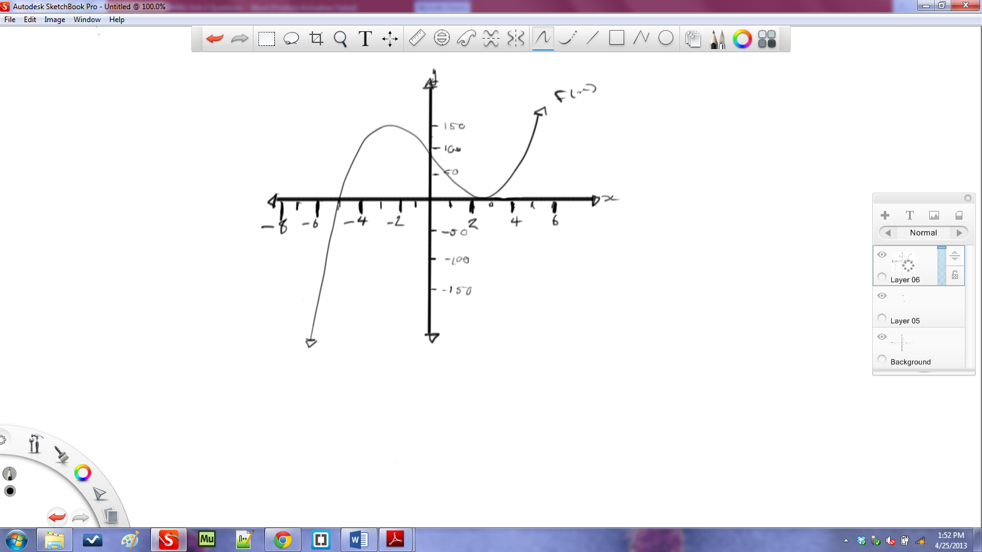

b)

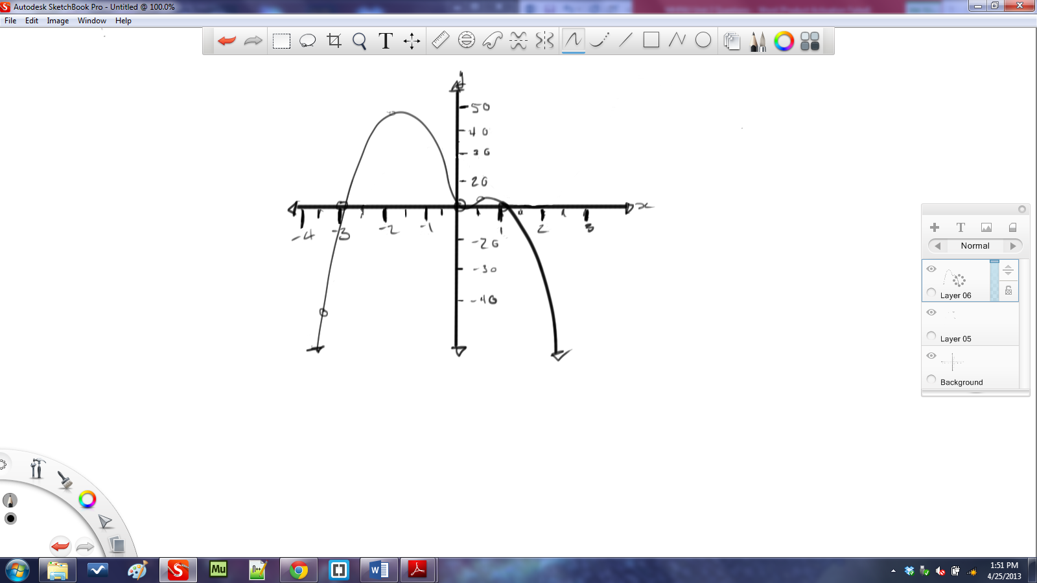

36.

37. a) Horizontal translation of 2 left  
 Reflection in the *x*-axis  
 Vertical translation of 5 down

b) Reflection in the *y*-axis  
 Vertical translation of 5 up

38.

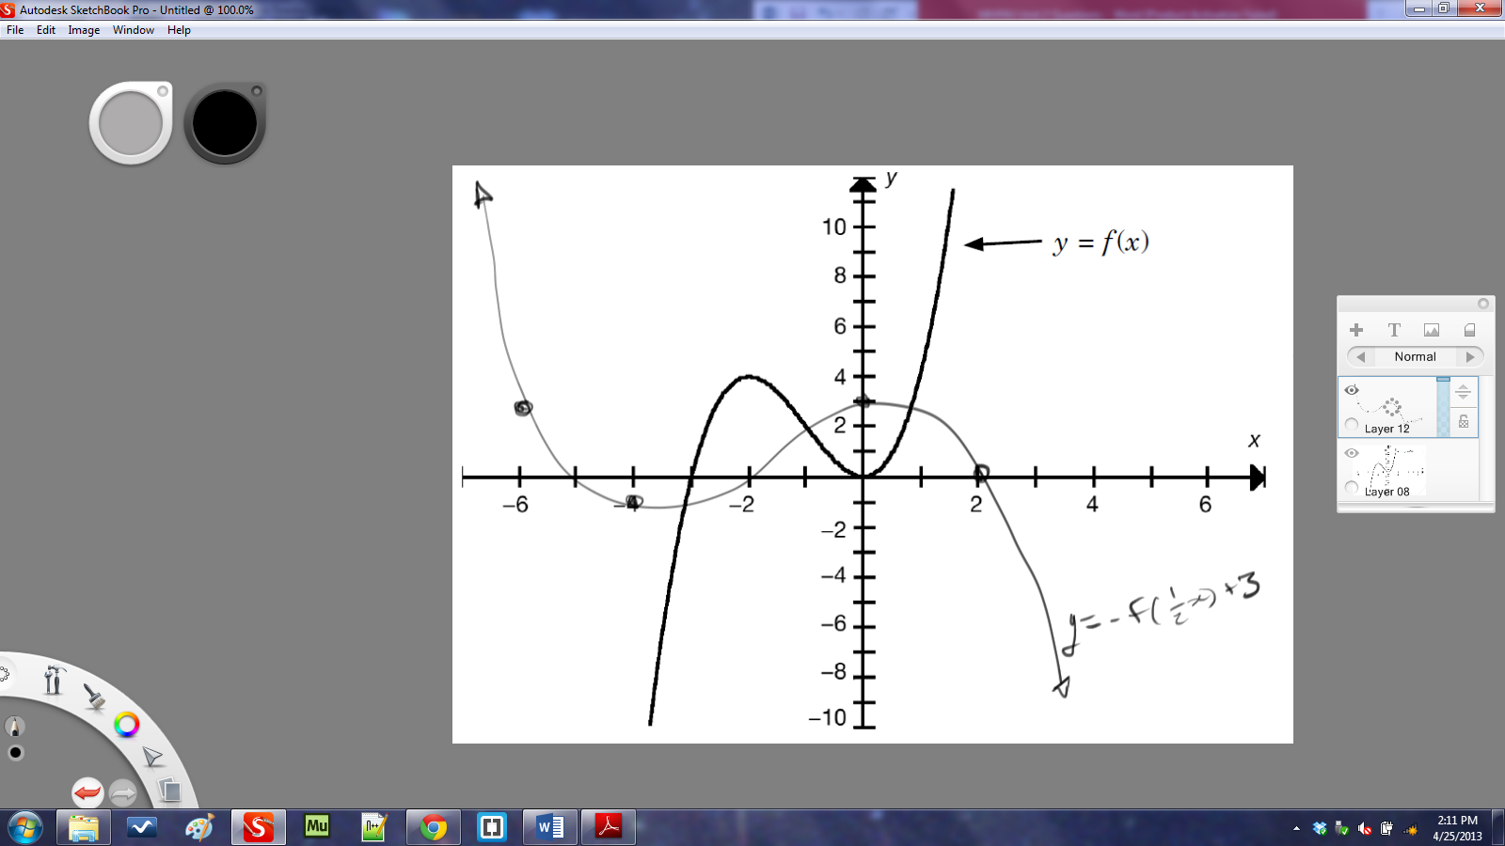

39. a) Neither  
 b) Even  
 c) Odd

40.

41. (a) and (b):

|  |  |  |  |  |
| --- | --- | --- | --- | --- |
| Equation | V.A. | H.A. | *x*-intercepts | *y*-intercepts |
| $$f\left(x\right)=\frac{4x+8}{x-3}$$ | $$3$$ | $$4$$ | $$-2$$ | $$\frac{8}{-3}$$ |
| $$f\left(x\right)=\frac{1}{x^{2}+4}$$ | none |  | None |  |

42. a)  
 b)

This function at no point equals zero because the H.A. is equal to 0 and 2 is not equal to 0 by basic arithmetic. Therefore,

43. Finding the equation: $$f\left(x\right)=a\left(x+4\right)\left(x-6\right)x \\ 8=a\left(4+4\right)\left(4-6\right)\left(4\right)=-64a \\ a=\frac{8}{-64}=\frac{1}{-8} \\ ∴f\left(x\right)=\frac{\left(x+4\right)\left(x-6\right)x}{-8} \\ \frac{1}{f\left(x\right)}=\frac{-8}{\left(x+4\right)\left(x-6\right)x}$$

Asymptotes are:

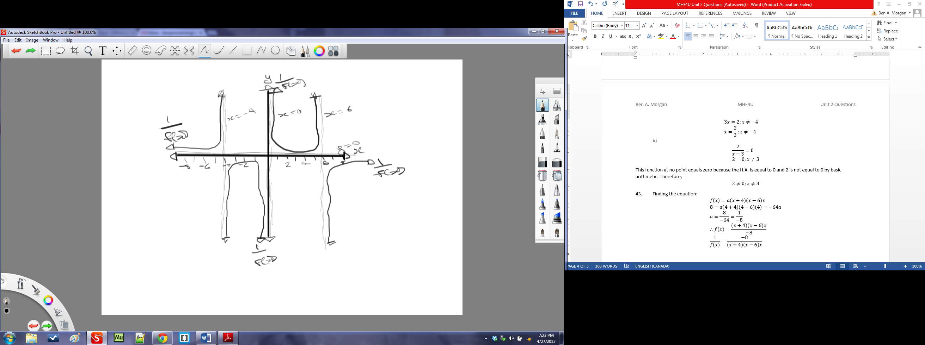

44. a) Asymptotes: $$x=±2 \\ y=4$$ 
*y*-intercepts: $-\frac{1}{4}$  
*x*-intercepts: none

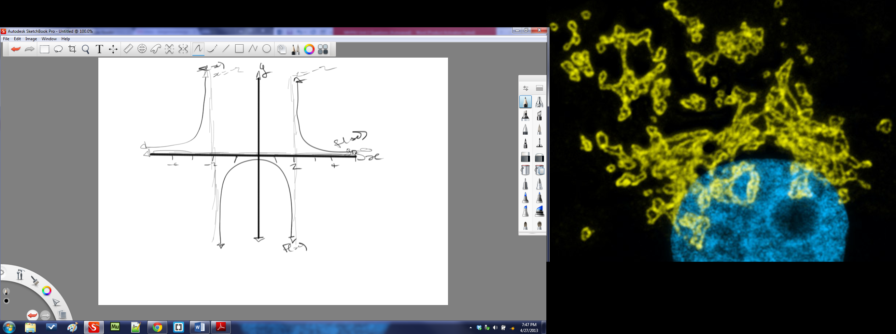

b) Asymptotes: $$x=-2 \\ y=1$$ 
*y*-intercepts: $-2$  
*x*-intercepts:

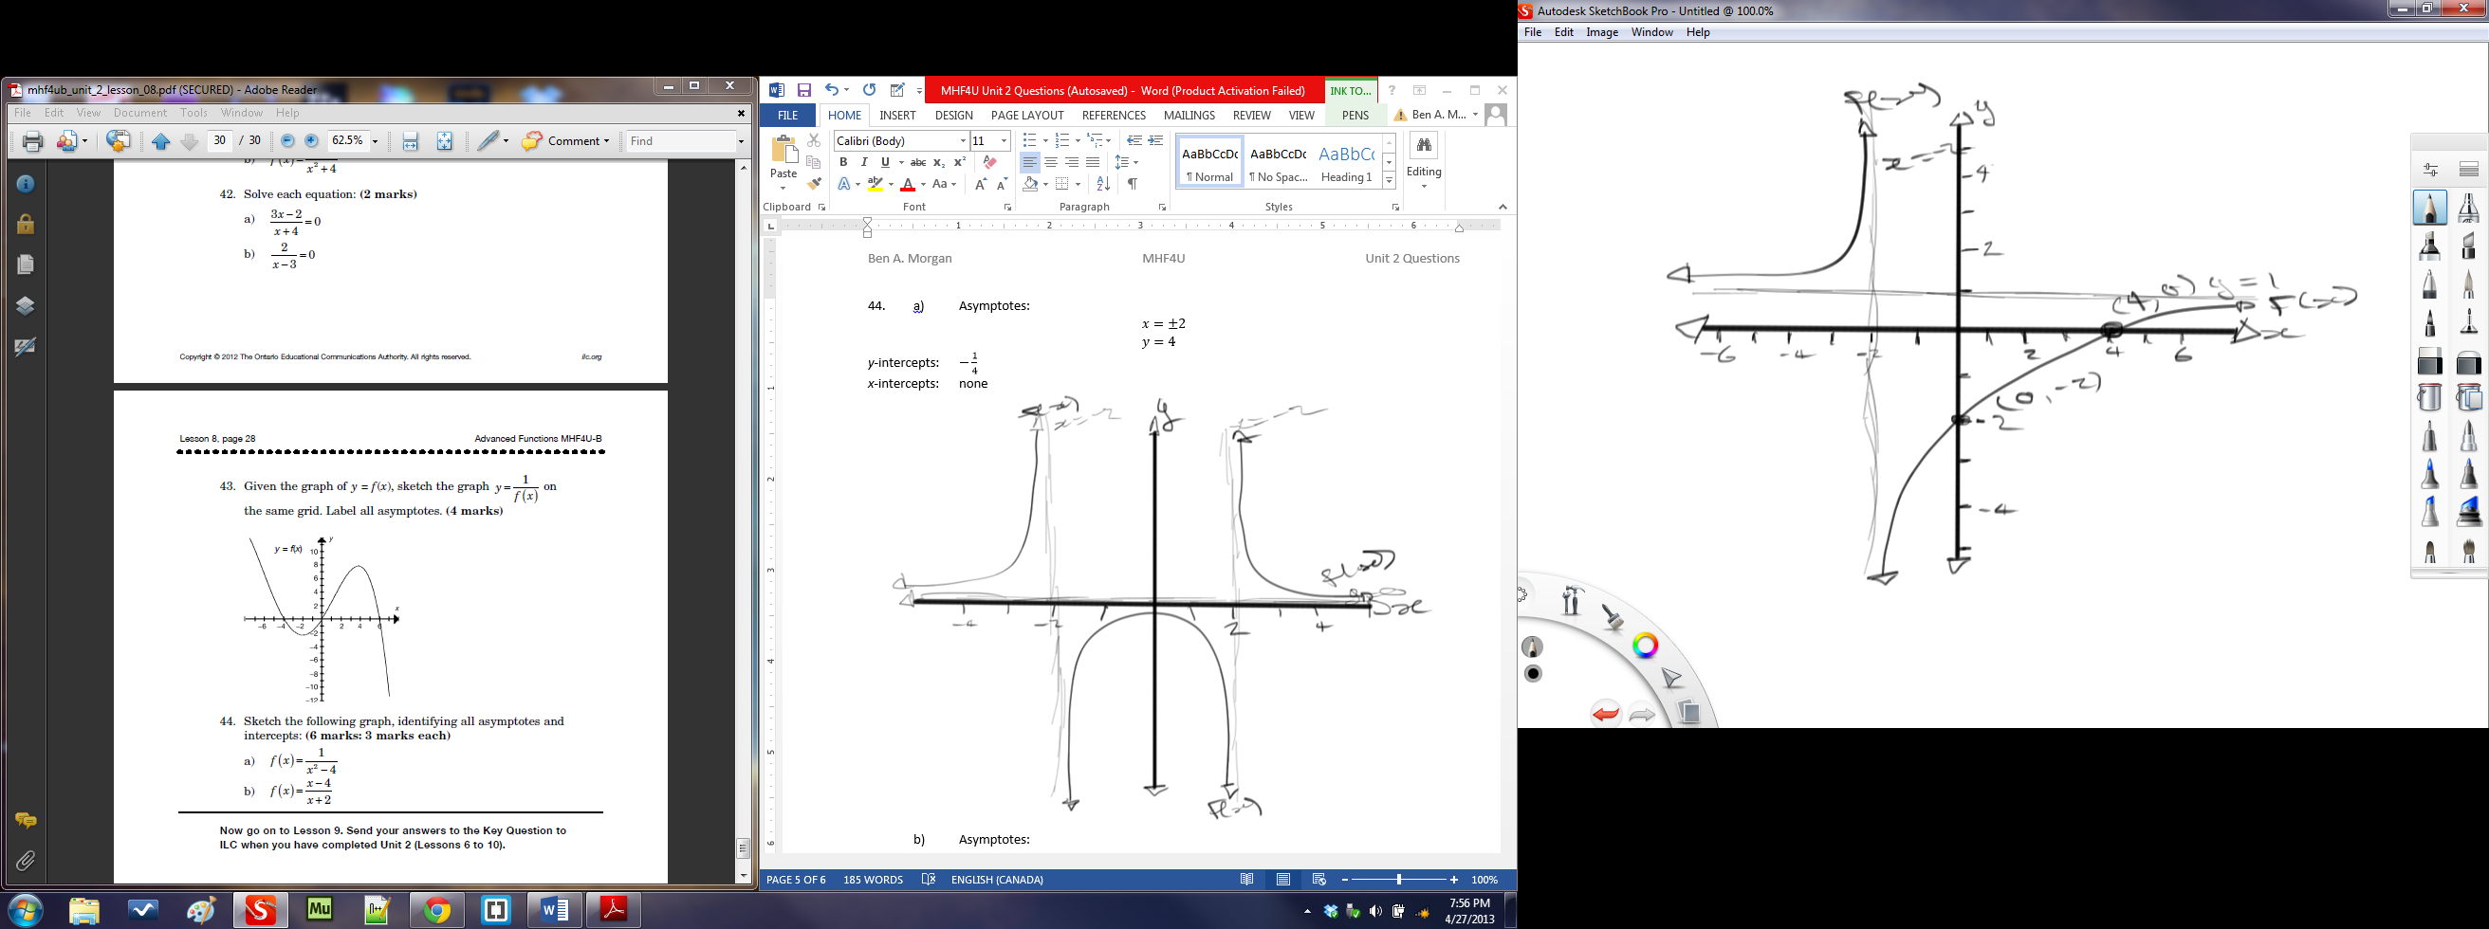

45. a)

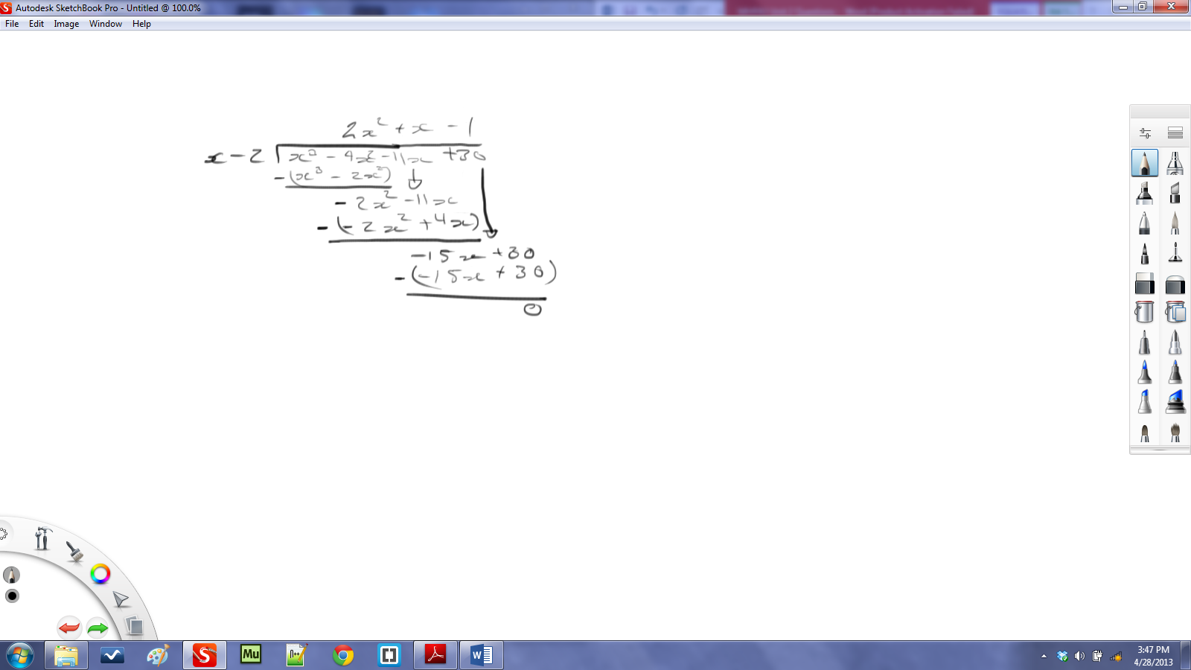2 >oes thince at no point doe

b)

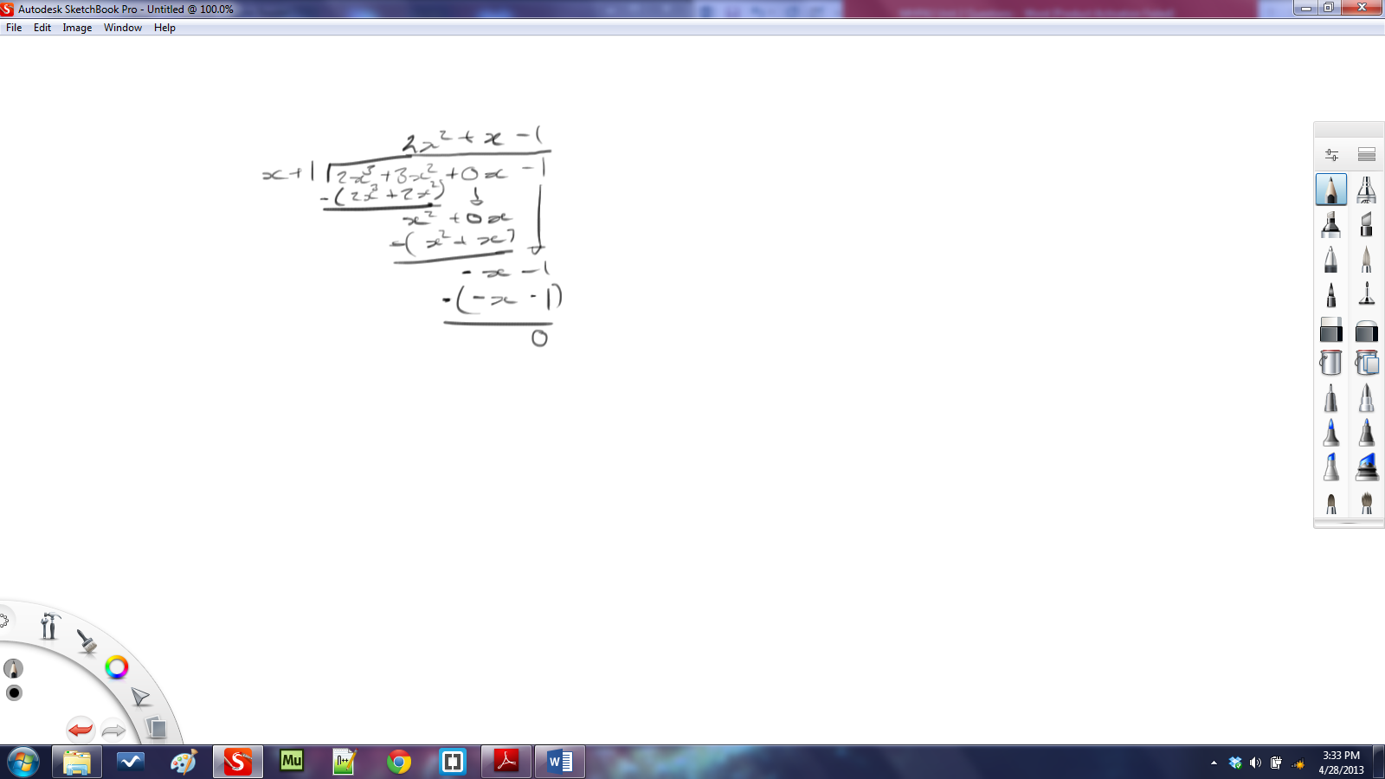

46.

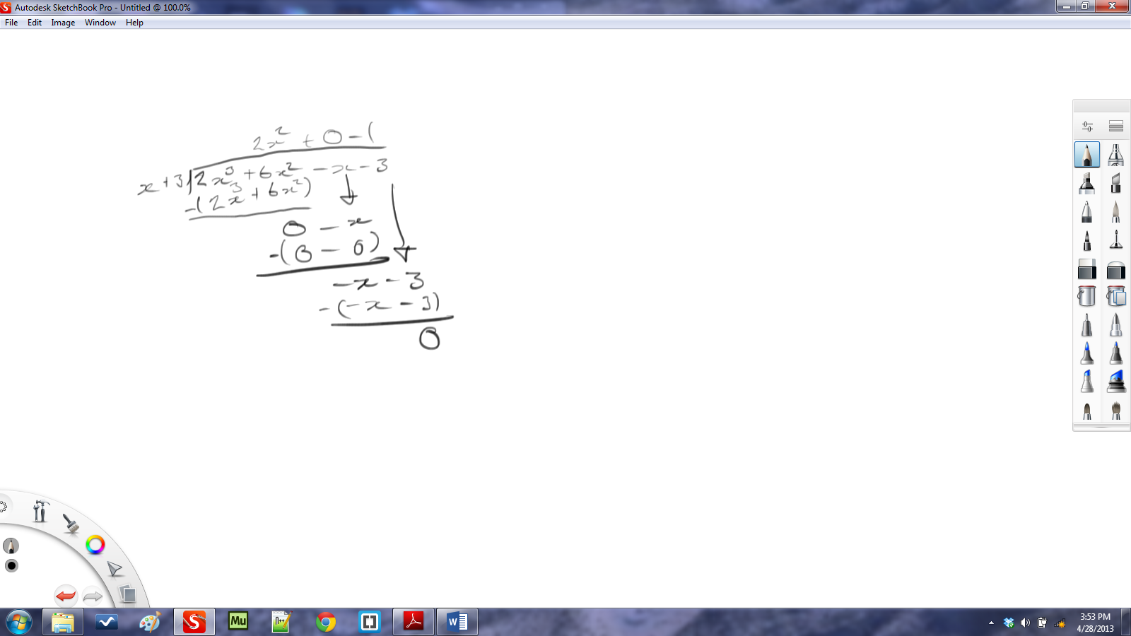  
=+6−

47. a)  
 b) For :

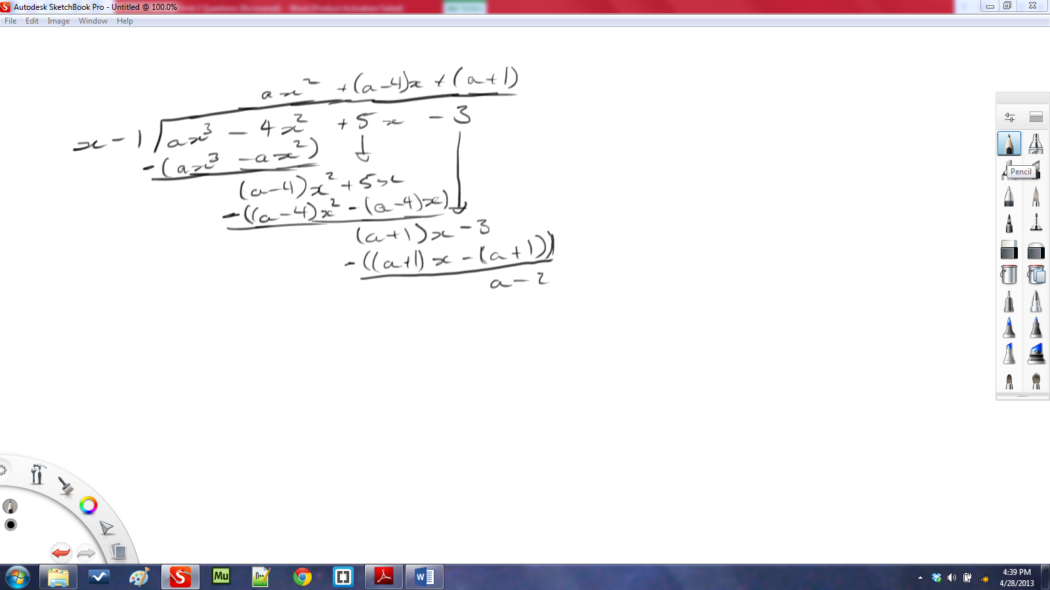

For :

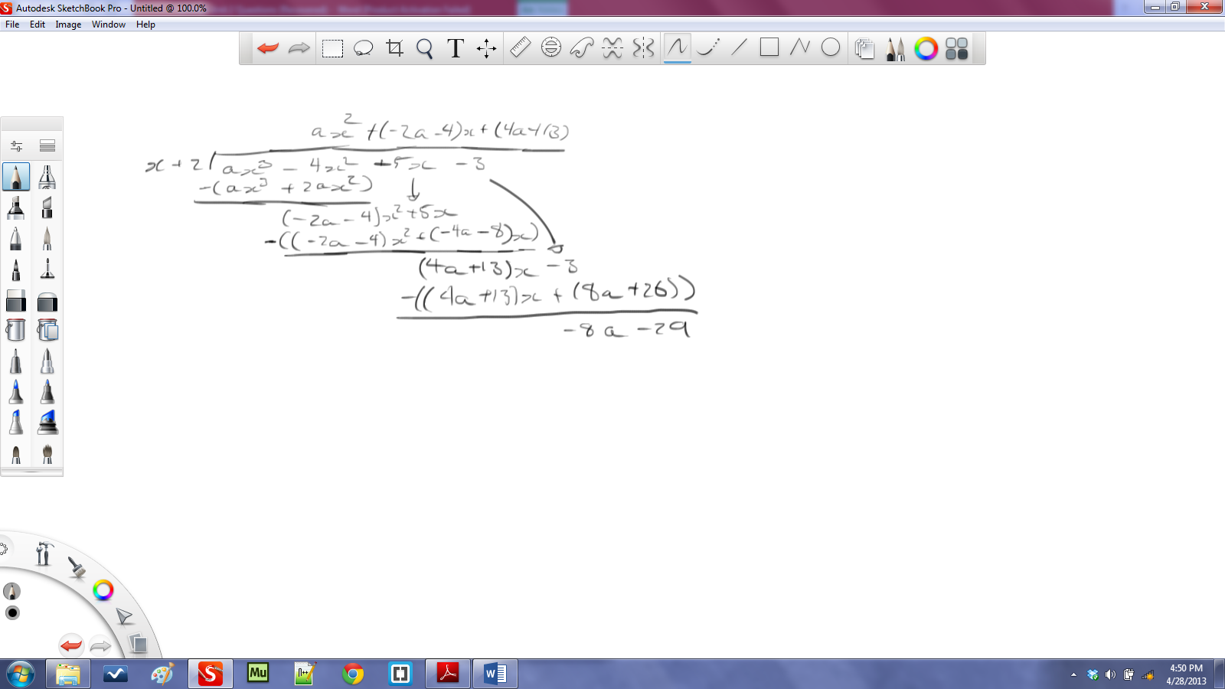

From the Remainder:

48. a)

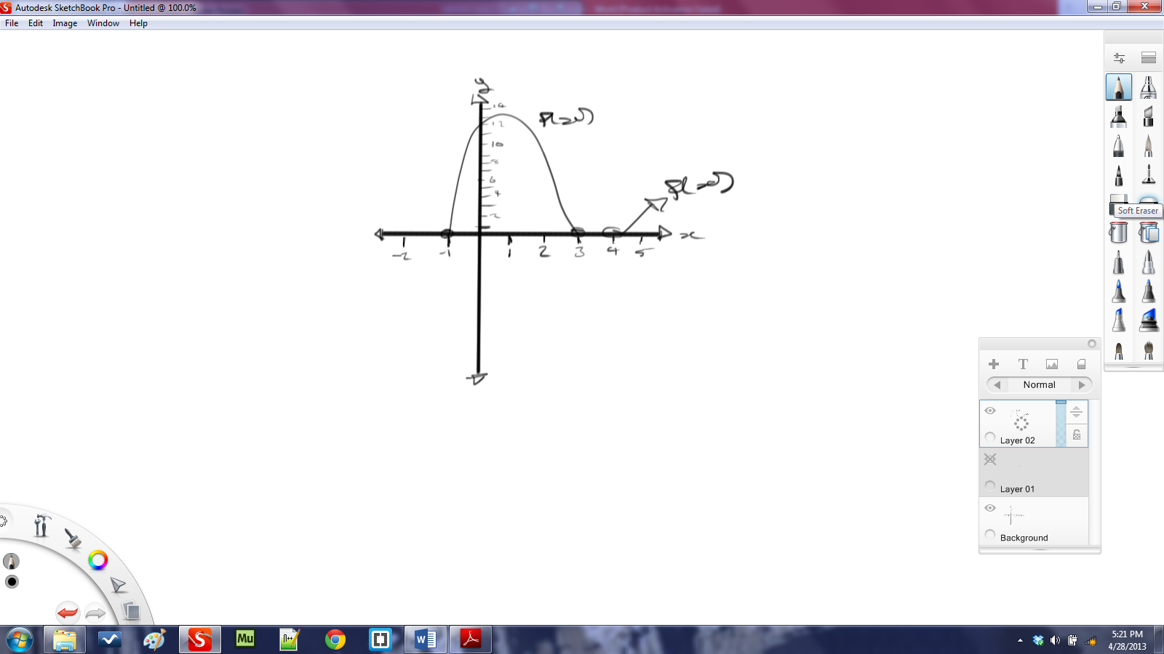

b)

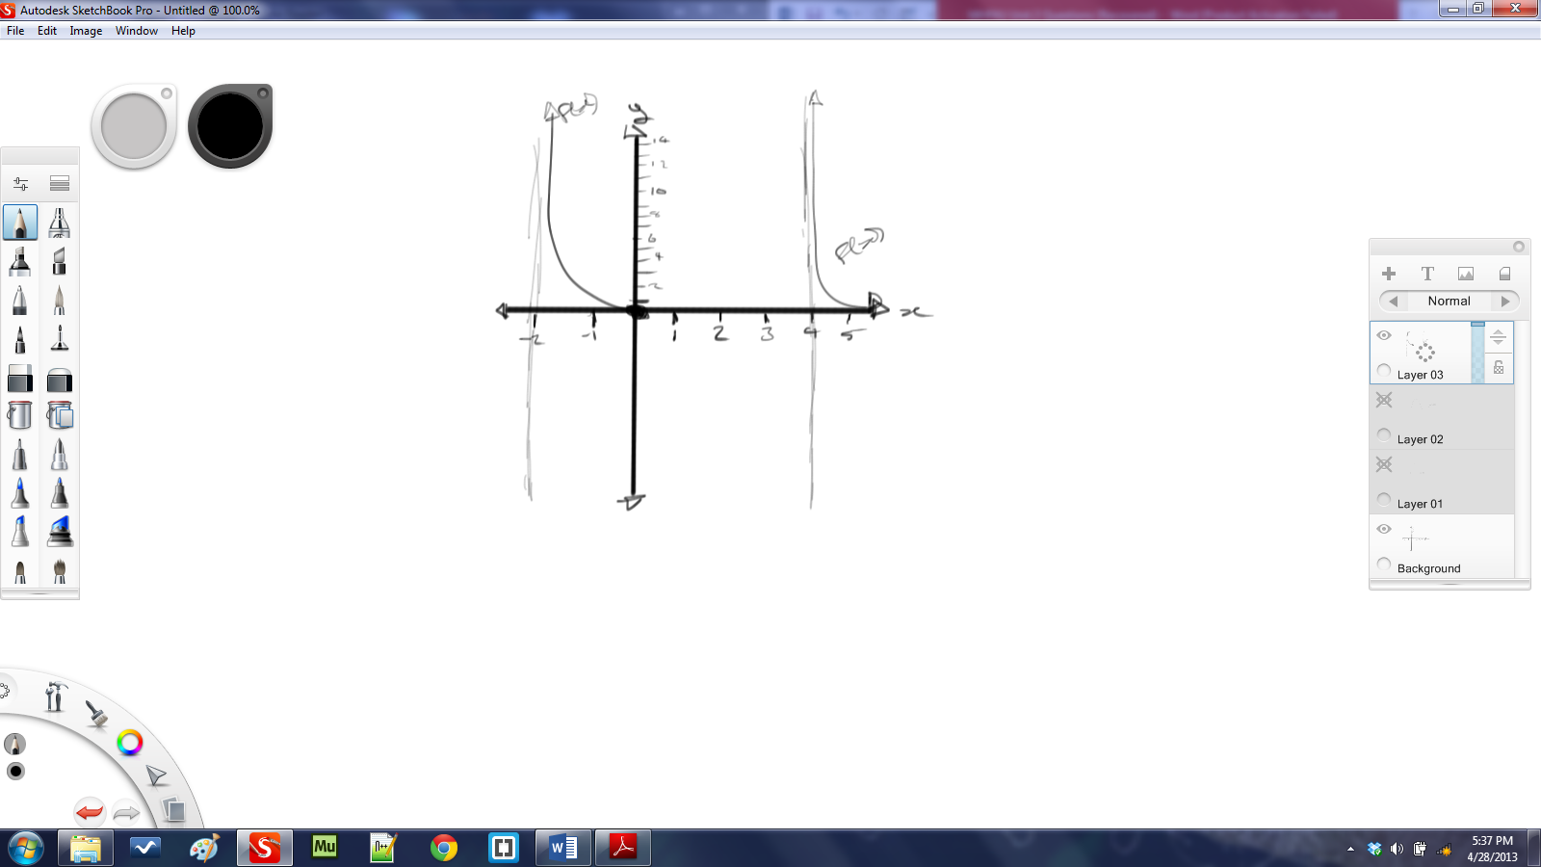

49. a)  
There is no solution since at no point was the function below or equal to zero.  
 b) $$0<\frac{3}{x^{2}-4}=\frac{3}{\left(x-2\right)\left(x+2\right)} \\ x<-2, x>2$$